**Employee Managing Desktop Application**

**CRUD REST API**

**C - Create New Employee :**

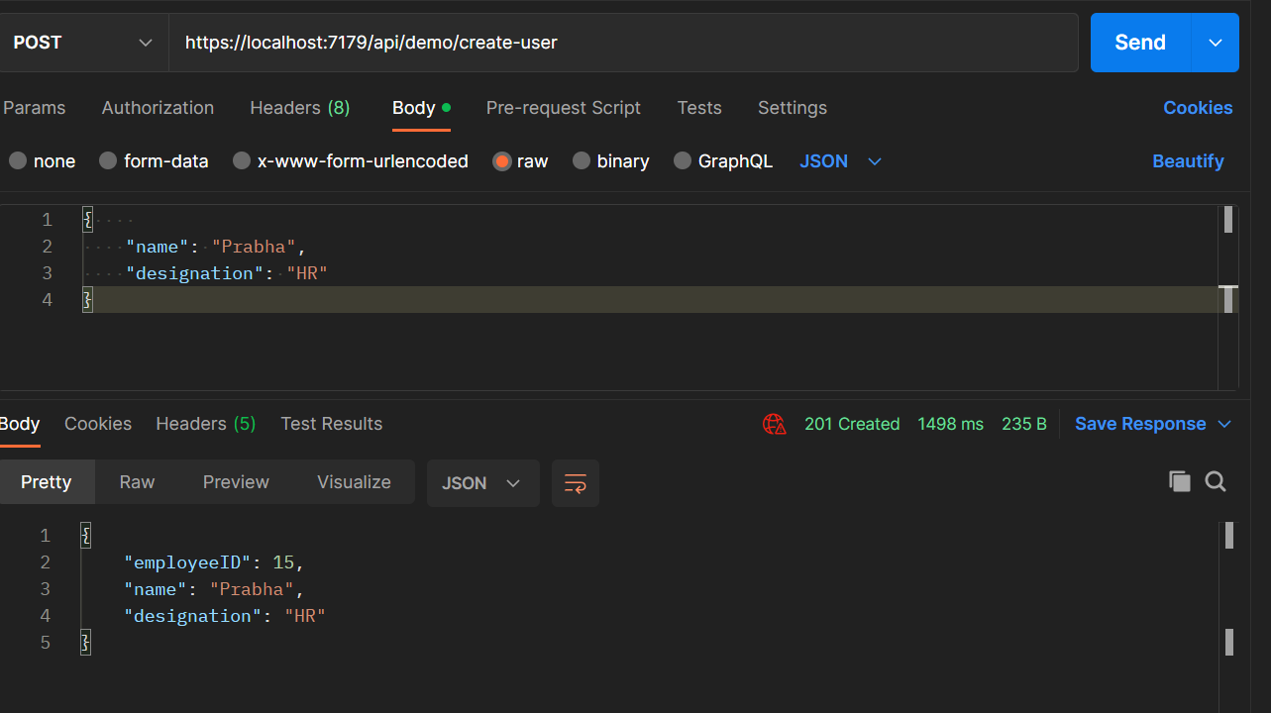

**R - Read Get all Employee Details**

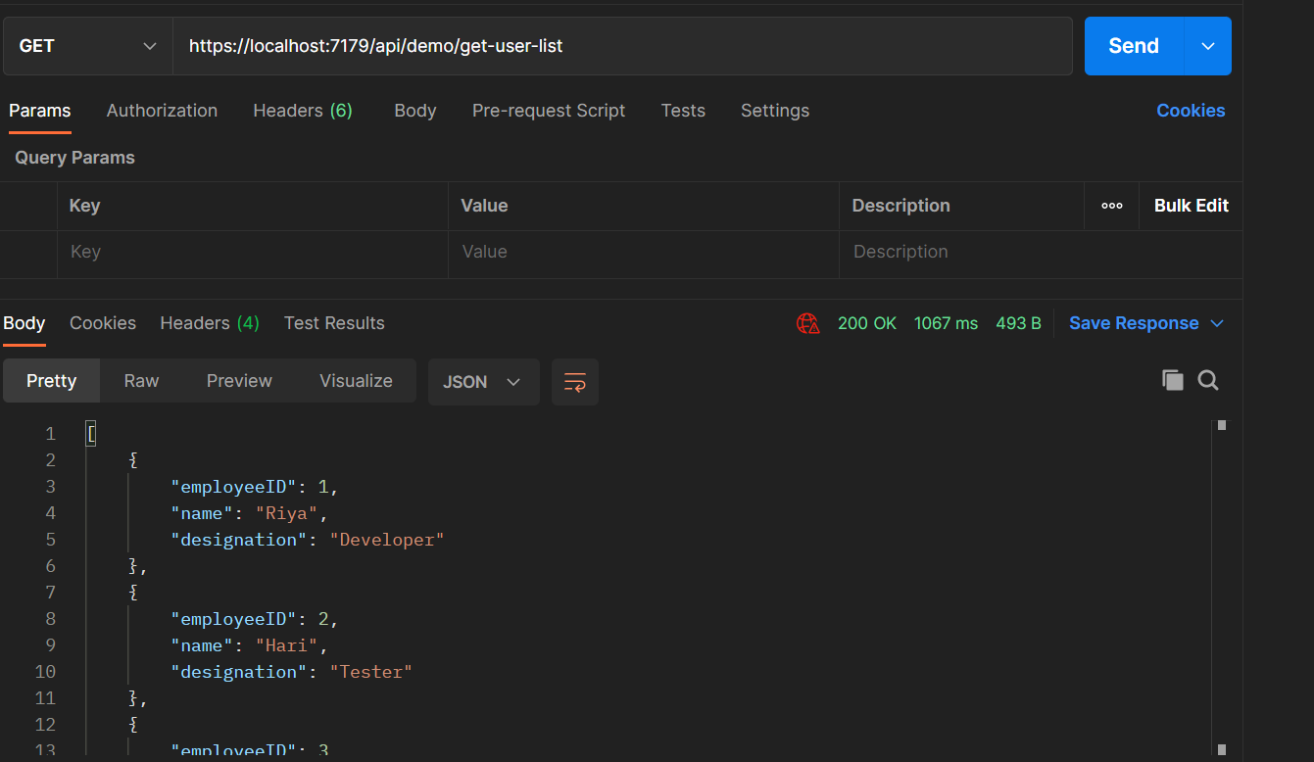

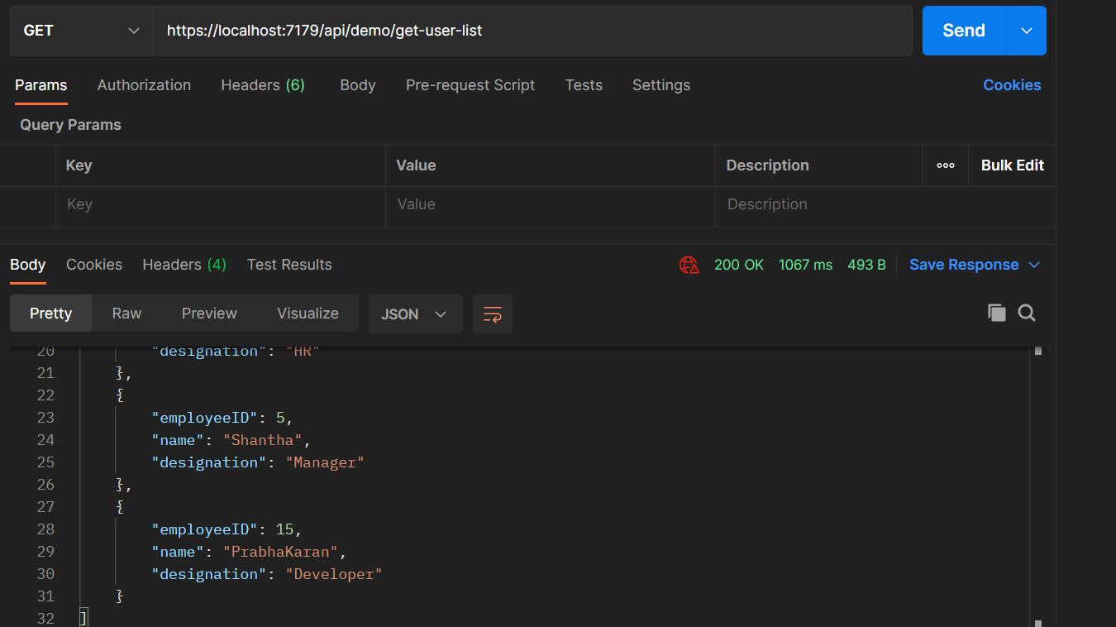

**Update Existing Employee :**

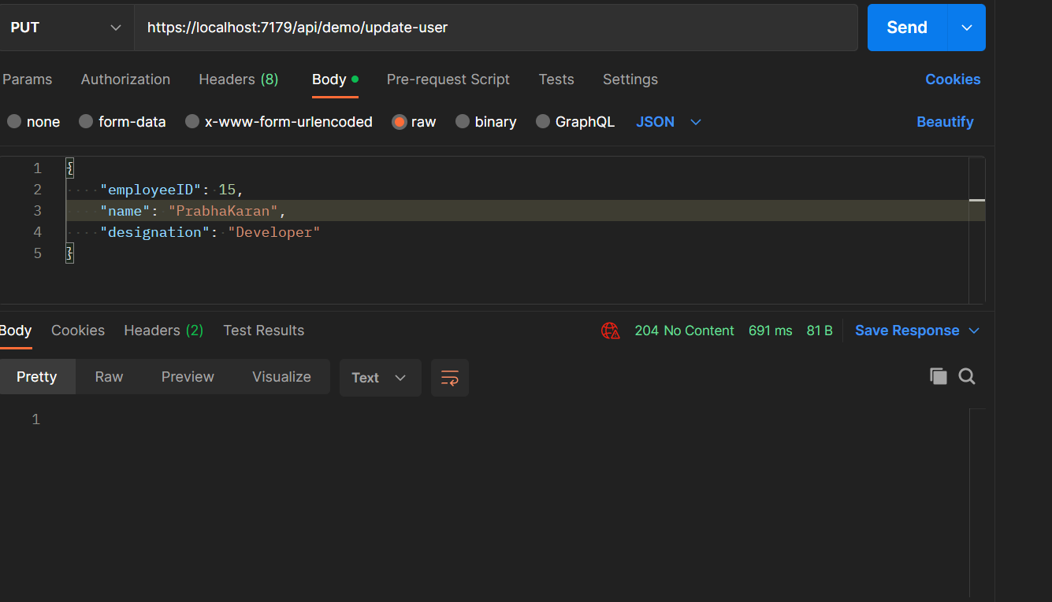

**D - Delete the Existing Employee**

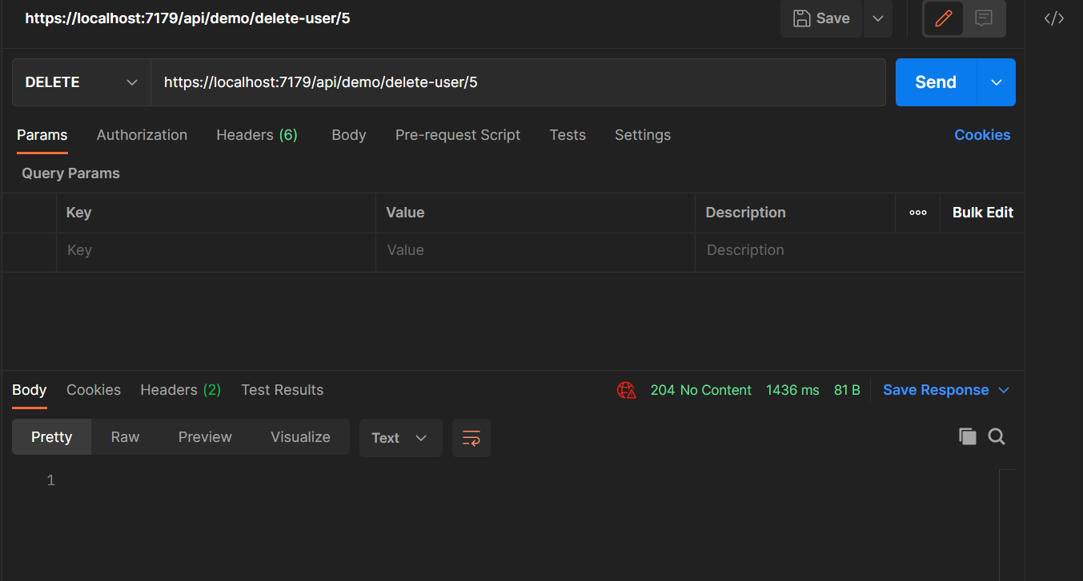

**Now 5th ID is deleted**

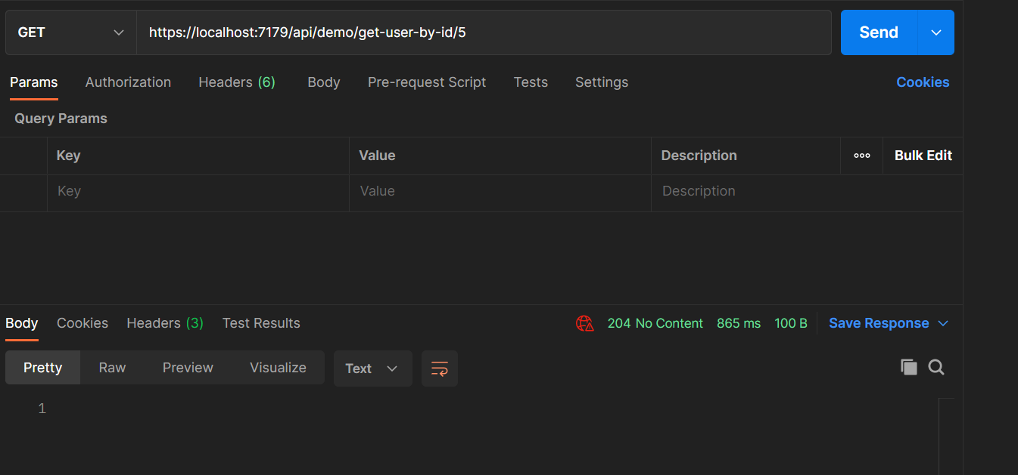

**Calling REST API in WPF Application**

**Click Load Employee Button - See all the employees**

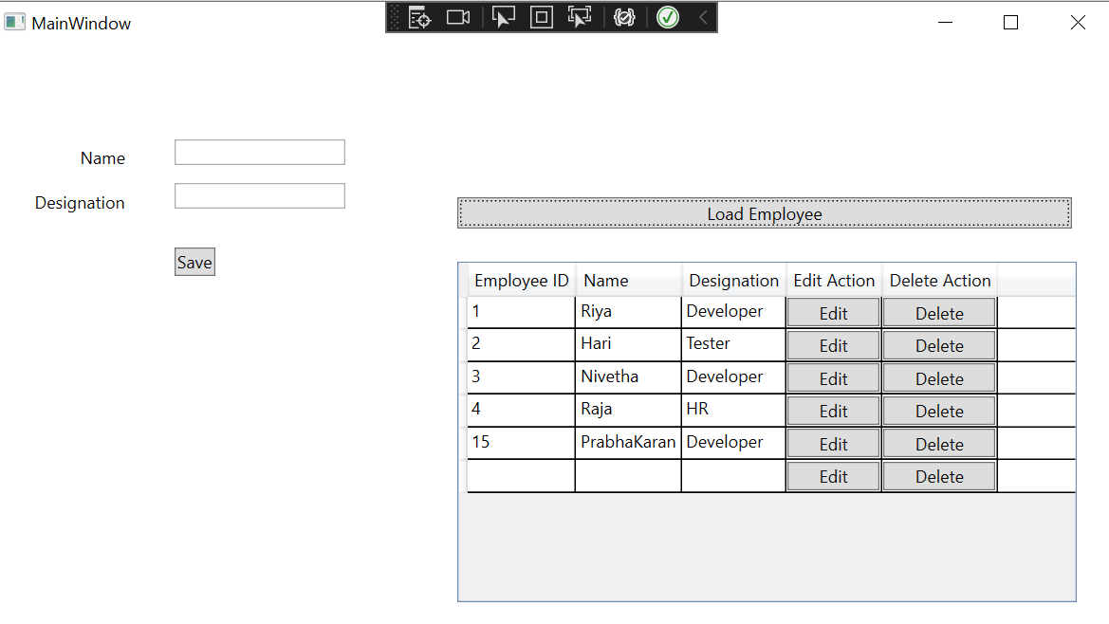

**Add New Employee**

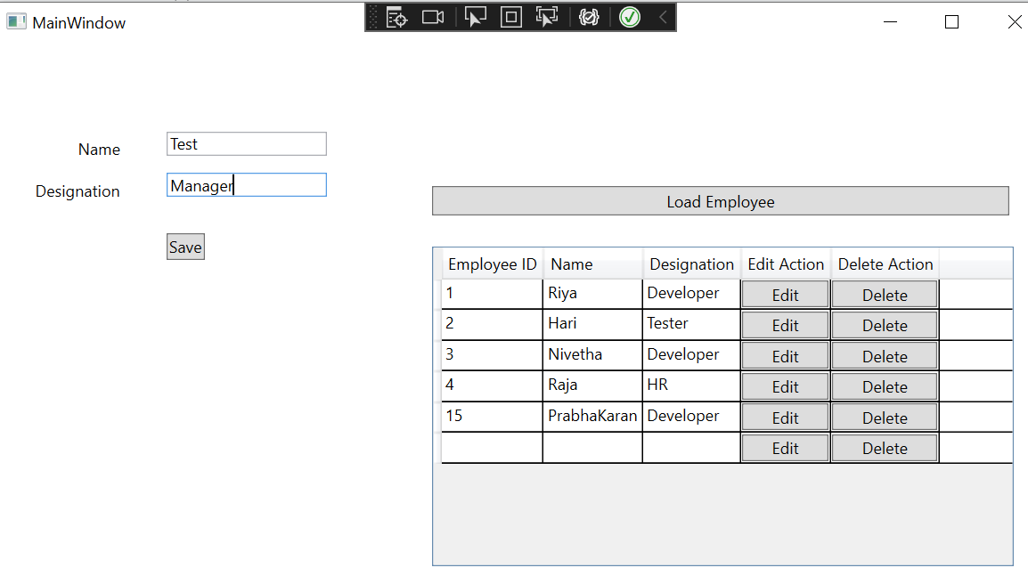

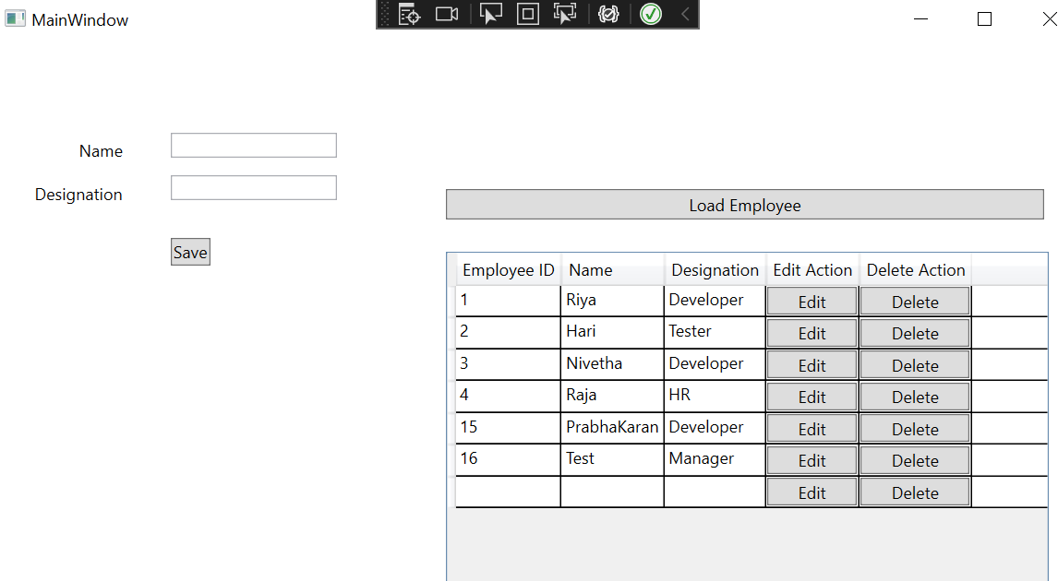

**Click Edit button to Edit 16th Employee Name**

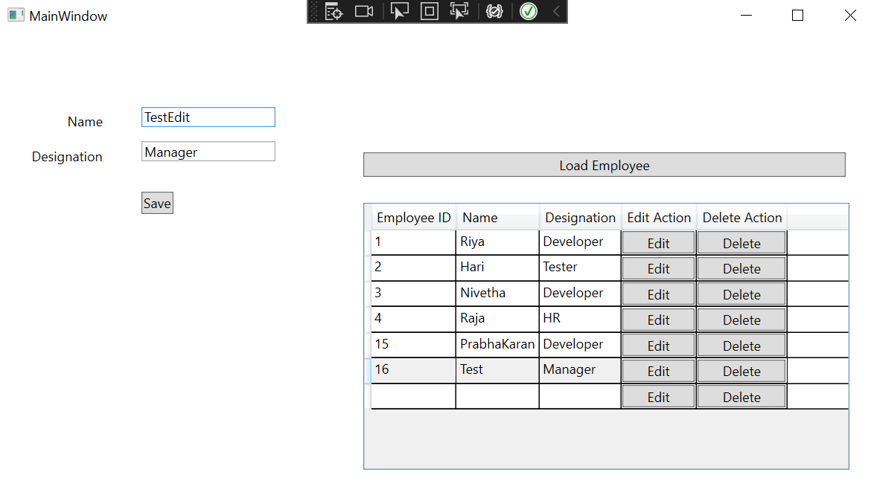

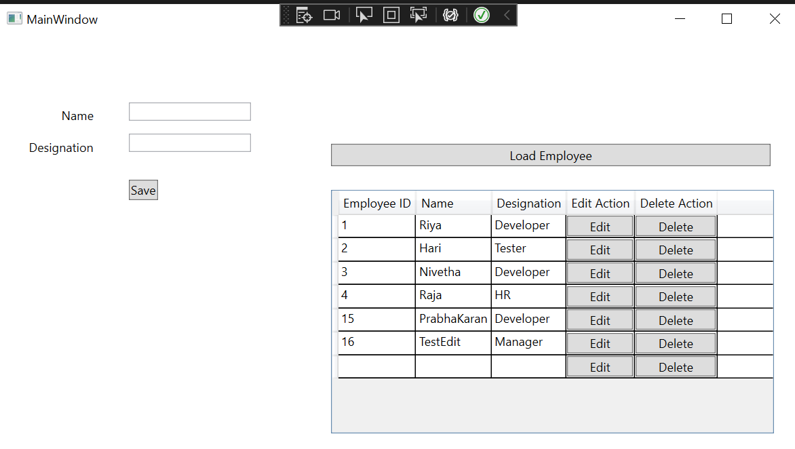

**Click Delete button to delete the 15th EMployee**

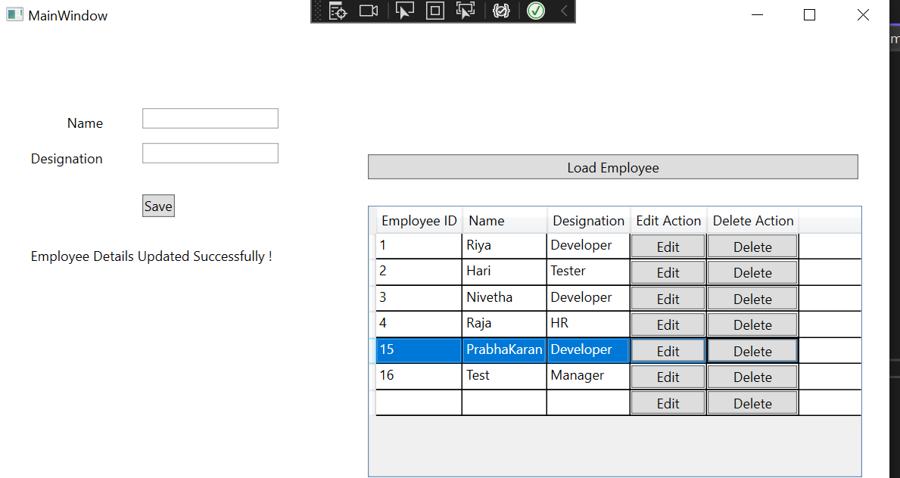

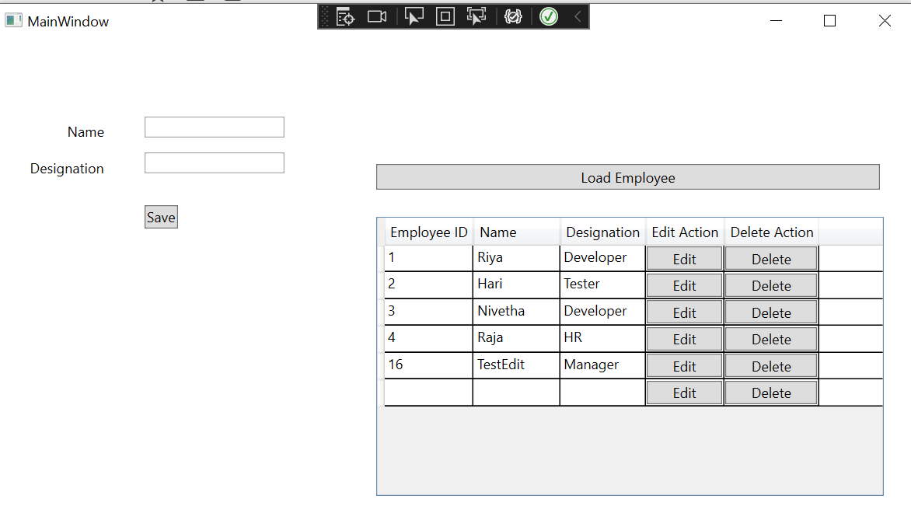

**—------------------------------------END Thank You !-------------------------------------------------**